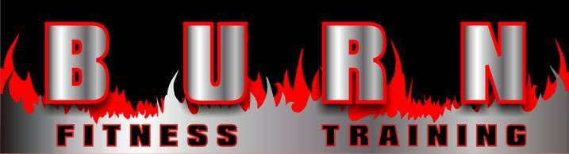
5023 Central Ave, St Petersburg, FL 33710

Name:
Contact Phone:
Contact Email:

Coaching Program Questionnaire
Rank the following goals by priority (Rank 1-6 with 1 being highest priority):
____ Weight Loss / Fat Loss / Toning
____ Muscle / Strength Gain / Weight Gain
____ Functional Ability / Athletic Performance / Balance
____ General Health / Pre-Existing Medical Condition Mitigation
____ Bodybuilding / Physique Competition / Aesthetic
____ Longevity / General Fitness / De-Aging
____ Other:

Current Stats:
Age:
Height: Weight: Weight History (last 3 years):
Chest Measurement (at areola, chest expanded):
Waist Measurement (at belly button, stomach sucked in):
Hip Measurement (at greatest circumference, glutes flexed):
Percent Body-Fat (if known): Measurement method:

Trainer / Coaching Experience?
Have you worked with a trainer or coach before? (Y/N)
If yes, was it a positive experience? (Y/N)
If positive/negative, please explain what you LIKED/DIDN’T LIKE:

Have you played team sport before? (Y/N) What sport?
Have you trained with training partner? (Y/N) Are you currently?
If yes, did you push them, or did they push you?

What are your biggest weaknesses (Rank 1-5)?
____ Training Intensity
____ Training frequency / consistency
____ Nutrition and Diet
____ Fitness Education
____ Long-term persistence / staying with it

Exercise and Equipment Availability:
Where do you currently STRENGTH TRAIN? (Large Gym, Small Gym, Condo Gym, Park, Home)

How often do STRENGTH TRAIN now?

Where do you currently do CARDIO/ENDURANCE TRAINING?

How often do you do CARDIO/ENDURANCE TRAINING now?

Time Availability:
How many hours do you work per week? Is it consistent (same days/times)?
When is the best time for you to exercise?
What conflicts interfere with your exercise (family, work, other)?
What time of day do you have the most energy?

Nutrition Habits:
How many meals and snacks do you eat per day?

Of those meals, how many do you prepare, and how many do you eat out?

Do you eat consistently (similar food much of the time)?

When you cheat… What foods do you cheat with? When? What TRIGGERS cheats (boredom, stress, temptation, alcohol)?

Have you ever tracked/journaled your eating?

What is you nutritional “education level”? (Calories, macro-nutrients, types of fat, types of protein)

Are you currently following a structured meal plan? (Attach to email if you can) (Y/N)

If yes, please provide your current plan:

Breakfast (Meal 1):

Meal 2:

Meal 3:

Meal 4:

Meal 5:

Daily Calories: ______________
Daily Protein: ______________
Daily Carbs: ______________
Daily Fat: ______________

Do you have any allergies that affect the way you eat? (Y/N)
Are these DIAGNOSED by an allergist? (Y/N)
What foods are you allergic to, or cannot eat?

